B.S. Computer Science Project Proposal



Title of Project

Month Year

Submitted By

M.Najeebullah Khan (BSCS/F14/0133)

M.Talal Malick (BSCS/F14/0145)

Saim Ahmed (BSCS/F14/0146)

Supervisor

Name of Supervisor

Supervisor’s Designation

DEPARTMENT OF COMPUTER SCIENCE

HAMDARD UNIVERSITY KARACHI,

MAIN CAMPUS

# Table of Contents

Contents

Title Page…………………………………………………………………………………………………………………………………………1

Table of Contents 2

Problem Statement 3

Objectives of Project 3

Literature Review 3

Paper based traditional restaurant system 3

SMART FOOD ORDERING SYSEM: 4

Methodology for Implementation of Project 4

SYSTEM ARCHITETURE 5

SYSTEM MODULES AND SYSTEM DESIGN: 7

PROJECT SCOPE: 8

FUNCTIONAL REQUIREMENT: 8

USER TABLET: 8

MANAGER'S TABLET: 8

KITCHEN DISPLAY: 8

SMS INTEGRATION: 8

MENU RECOMMENDATION: 8

CUSTOMER FEEDBACK: 9

REPORT GENERATION: 9

Non-Functional Requirements: 9

Team Actors with Roles: 9

References 10

# Problem Statement

Nowadays each and every hotels and restaurants use the conventional pen and paper method for ordering and serving food items which takes time and energy cause the customer dissatisfaction and loses restaurant reputations. This is the common manual process ordering food in hotels and restaurants. It involves several steps that the customer searches the name of the item in the menu card then waiters noting down the order according to the customer, transfers the order to the kitchen unit, serving the order, and then prepare the bill from the cashier counter. This process is conventional and too sluggish. It requires more manpower which creates human errors, and also consumes a lot of time.

# Objectives of Project

* Develop the smart system to automate food ordering process.
* To improve efficiency and accuracy in order processing.
* Develop a restaurant ordering system with mobile application based on  
  the client server application.
* Reduce Human error to get positive feedback from customers.
* To reduce wastage of money, time, and paper.
* This system determines best selling food items, hot hours, and customers satisfaction.
* Use tablets and smart phone to communicate between customer and staff through mobile app.

# Literature Review

## Paper based traditional restaurant system

Worldwide a conventional pen paper based system is one of the most commonly used for food ordering. In this process all the records store on the paper which creates various problems such as:

* + The most common blunder iswaiter to make mistake while taking orders from the customer. Mostly specific details and orders of the customer are relied on waiter to remember it.[1]
  + Wasting the waiter’s service time by calling them frequently from customers to know about their order status.[1]
  + Managers have to search hundreds of receipt papers to find whicharethe best selling food items, popular hot hours, and customer positive responses.[1]
  + When food item/s not available or price need to be changed, updated menu card will be re-print again and again.[1]
  + Large amount of human efforts required with less efficiency.[1]

## SMART FOOD ORDERING SYSEM:

* + - Smart food ordering system based on electronic devices with the screen presenting the food items menu accept user’s input through the mobile and web based application for order placing.
    - Only the available dishes will be shown in menu on screen.
    - A customer chooses the items from menu and place their orders through web based or mobile based application which will sent to the kitchen unit and admin too.
    - Kitchen staff checks the order from installed device in the kitchen then would prepare the dishes or items according to the customer order.
    - After completion of order waiter will be called who collect and deliver or serve the items to appropriate customer.
    - After serving the order the counter will generate a copy of bill for customer automatically. Customer can also view and calculate his respective food items according to the prices.
    - Customer will choose the payment method (Cash, Debit Card, PayPal etc) according to his ease in application.
    - The management will have full authority to access all details of the customer which are fed into the customer.

# Methodology for Implementation of Project

The SDLC model, which includes Planning, Analysis ,Design, Implementation, and maintenance involves breaking down of the software development life cycle into smaller modules. However, integrating documentation and quality testing is involved at every step. To clarify this more let us have a look at the principles.

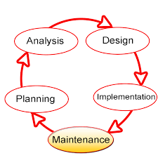

Figure 3

# SYSTEM ARCHITETURE

The system architecture of customizable onlinefood ordering system using web basedapplication is shown. The architectureincludes the three mainareas of restaurant: theServer, the Kitchen, and the Cashier counter.Conceptually this system is built using followingcomponents: The android application is used to make ordersfrom tablet. The restaurant-owner’s laptop/tablet will keeptrack of customer records and also customizemenu using server application. The central database is used for restaurant-ownerto store updated menu information and orderdetails. Three main areas of restaurant are connectedusing wireless technology. The Android application is used to find out thelocation in restaurant according to its latitudeand longitude.

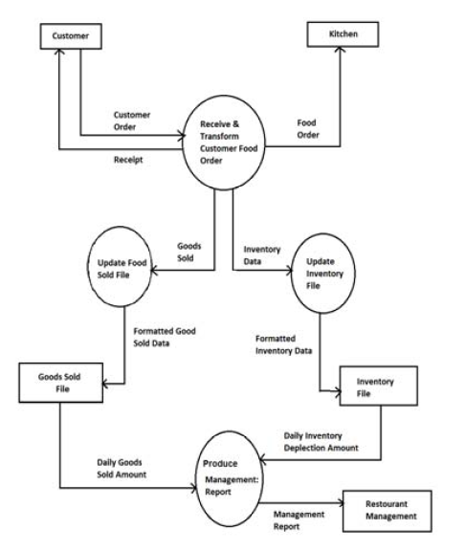

Figure

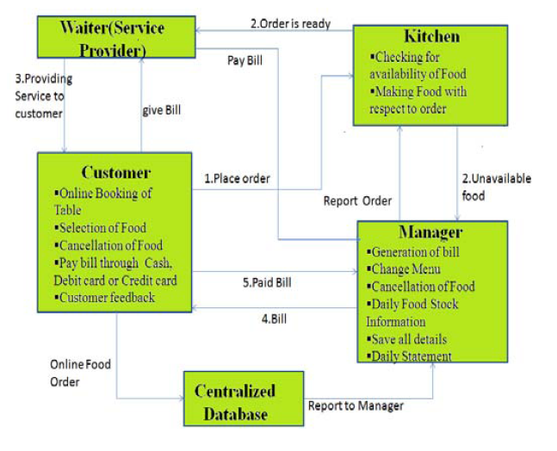

Figure

# SYSTEM MODULES AND SYSTEM DESIGN:

The restaurant owner or manager will have authority to log into the system and update the menu as per the availability of thedishes. The manager will also advertise the various offers of theday. Manager will dynamically add different categories of food.After arrival of customer in restaurant, he or she select theinformation and menu from tablet then this order is sent to thesystem over wireless network. The restaurant manager or ownerand the kitchen staff will receive the ordered lists from thecustomer tablet or system. The restaurant owner can update theorder status into the system.[2] The customer can also view the order status and he has authority to cancel the order. The wholeapplication will already be installed and kept open on the tabletson the tables. Customer who is outside the restaurant will booktable in restaurant or he will give order from his smart phone.The turn-off or shutdown option of the application will remaindisabled for the customers i.e. the customers can not be able toturn off theapplication and do any other work on the tablets.After having the food, customer can make paymentby online orby cash and enter feedback regarding to that restaurant systemfacility and services. Customer contact number will be saved indatabase for sending massage about next offers.[2]

# PROJECT SCOPE:

## FUNCTIONAL REQUIREMENT:

This project consists of the following modules as follows:

## USER TABLET:

This type of the tablets is especially made for thenormal users coming in the restaurant. First customer has to be done registration afterregistration he/she will get password and user namethen he/she can order process .Bill is automatically goes to that particular userThese tablets will consist of the whole menu of the restaurant. The items in the menu are non –editable for these types of the tablets.During registration process customer has to be enterpin code .customer can give order from any cityto any branch of restaurant using pin code.They will be enabled with the

Wi-Fi connectivity. Customer from any layer of the society should beable to handle and operate all the functions easily.

## **MANAGER'S TABLET:**

These desktops are especially for the use of therestaurant manager. The manager should be able to control the function of whole restaurant from a single desktop/tablet. He can access any tablet and should be able tomake changes to the menu. Also he can change price of particular item ordisable particular item which is not available at thatparticular time.

## KITCHEN DISPLAY:

These are present at the kitchen nearchef so that heshould be able to see what a particular has ordered. All the ordered items are displayed on the screengiving the table number below. They should be sufficiently large to be seen by chefat a reasonable distance. Chef should be able to notify when a particular item is ready.

## SMS INTEGRATION:

At the time of registration customer has to be enter the contact number & other information, this contact number & other information will saved in database.If there is any offer in restaurant then server will automatically send SMS to the customer.

## MENU RECOMMENDATION:

We are providing menu recommendation to the customer such as if customer order any menu thenour system will shows related menus to that order.

## CUSTOMER FEEDBACK:

We also provide facility to the customer to givefeedback about services of restaurant.

## REPORT GENERATION:

System generates Daily, Weekly& Monthly report.

## Non-Functional Requirements:

* User Feasibility
* Reduce human error.
* Quality.
* Automation.
* Reduce expenses.
* User’s Preferences.
* Reduce Staff
* Reduce Labor.
* Efficiency.
* Accuracy.
* Easy Updateable.
* Proper record Management.
* Robust.
* Save Time and money.

# Team Actors with Roles:

|  |  |  |  |  |
| --- | --- | --- | --- | --- |
| **Step No.** | **Description** | **Talal Malick** | **Najeeb ullah khan** | **Saim Ahmed** |
| 1 | Initiation |  |  |  |
| 2 | Planning |  |  |  |
| 3 | Elicitation |  |  |  |
| 4 | Design |  |  |  |
| 5 | Development |  |  |  |
| 6 | Database |  |  |  |
| 7 | Testing |  |  |  |

# References

[1] S. Sarkar, R. Shinde, P. Thakare, N. Dhomne, and K. Bhakare, “Integration of Touch Technology in Restaurants using Android,” *Int. J. Comput. Sci. Mob. Comput.*, vol. 3, no. 2, pp. 721–728, 2014.

[2] V. Chavan, P. Jadhav, S. Korade, and P. Teli, “Implementing Customizable Online Food Ordering System Using Web Based Application,” vol. 2, no. 4, pp. 722–727, 2015.